**Daily Scrum or Standup Meeting**

Team name: ________Group 2_________________

Scrum Master: ______Emily_________________

Date:_________10/26______________________

| **Team Member** | **What did you do since the last scrum?** | **What do you plan to do before the next scrum?** | **What obstacles do you have?** |
| --- | --- | --- | --- |
| Emily | Connected user balances, users can update their balance | Have employees add hours worked to their account | Time |
| Karl | Update the stylin of tables | Fix my many to one relationship with orders | Understanding the concept in detail. |
| Maris | Reviewed others’ progress… | Make order model | Knowing who/how to help |
| Andre | Wrapped up the Menu Item Model. A Menu Item Model is connected to a Inventory Item | Create the add new Menu Item Model, Remove Menu Item Model, and Delete Menu Item Model | Understanding the Many to Many relationship |
|  |  |  |  |

# Burndown

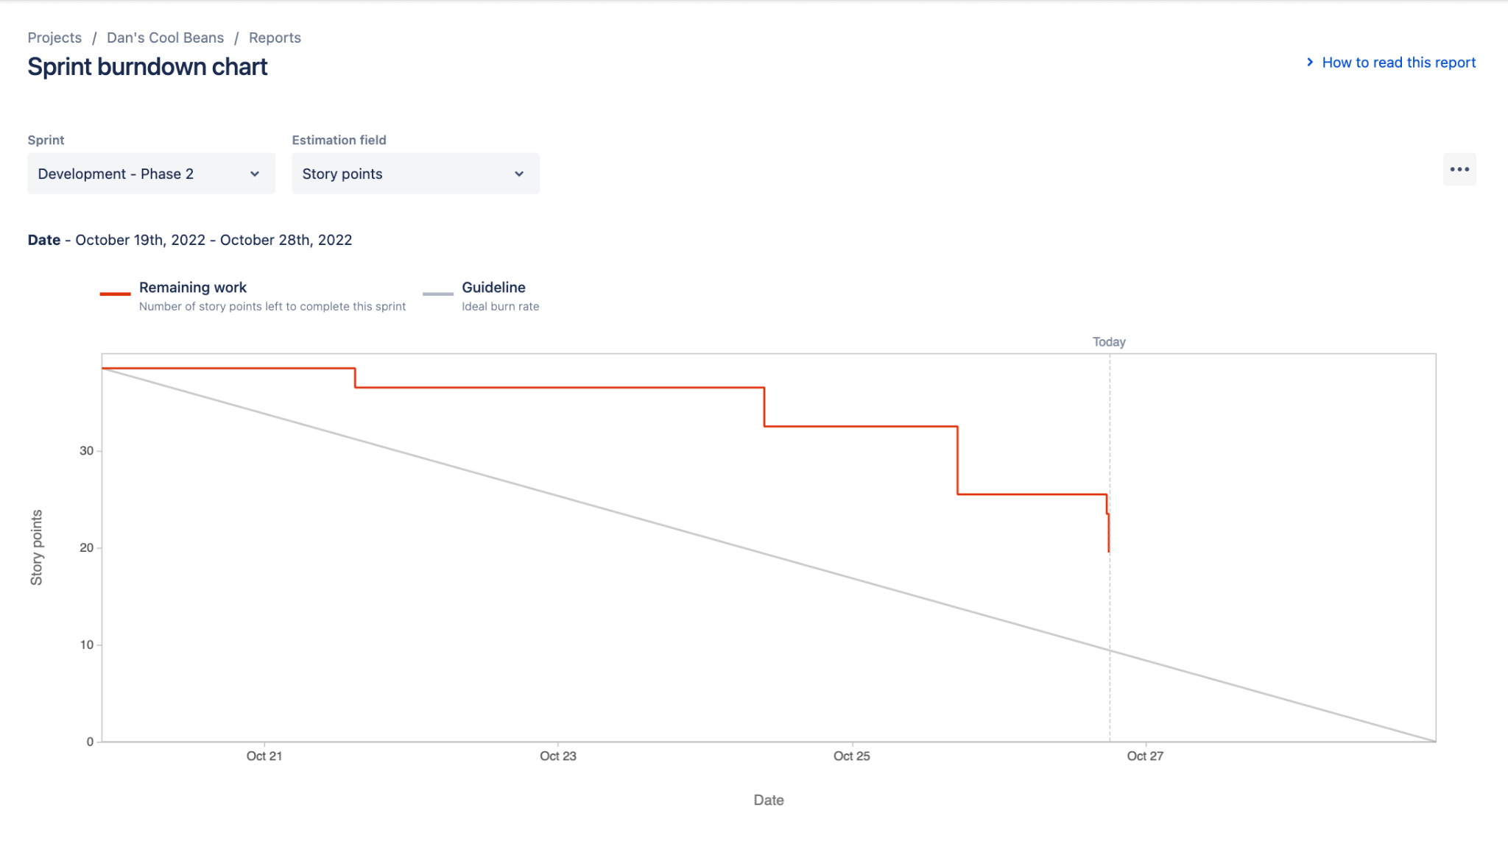

# Screenshot of you project board

